**About**

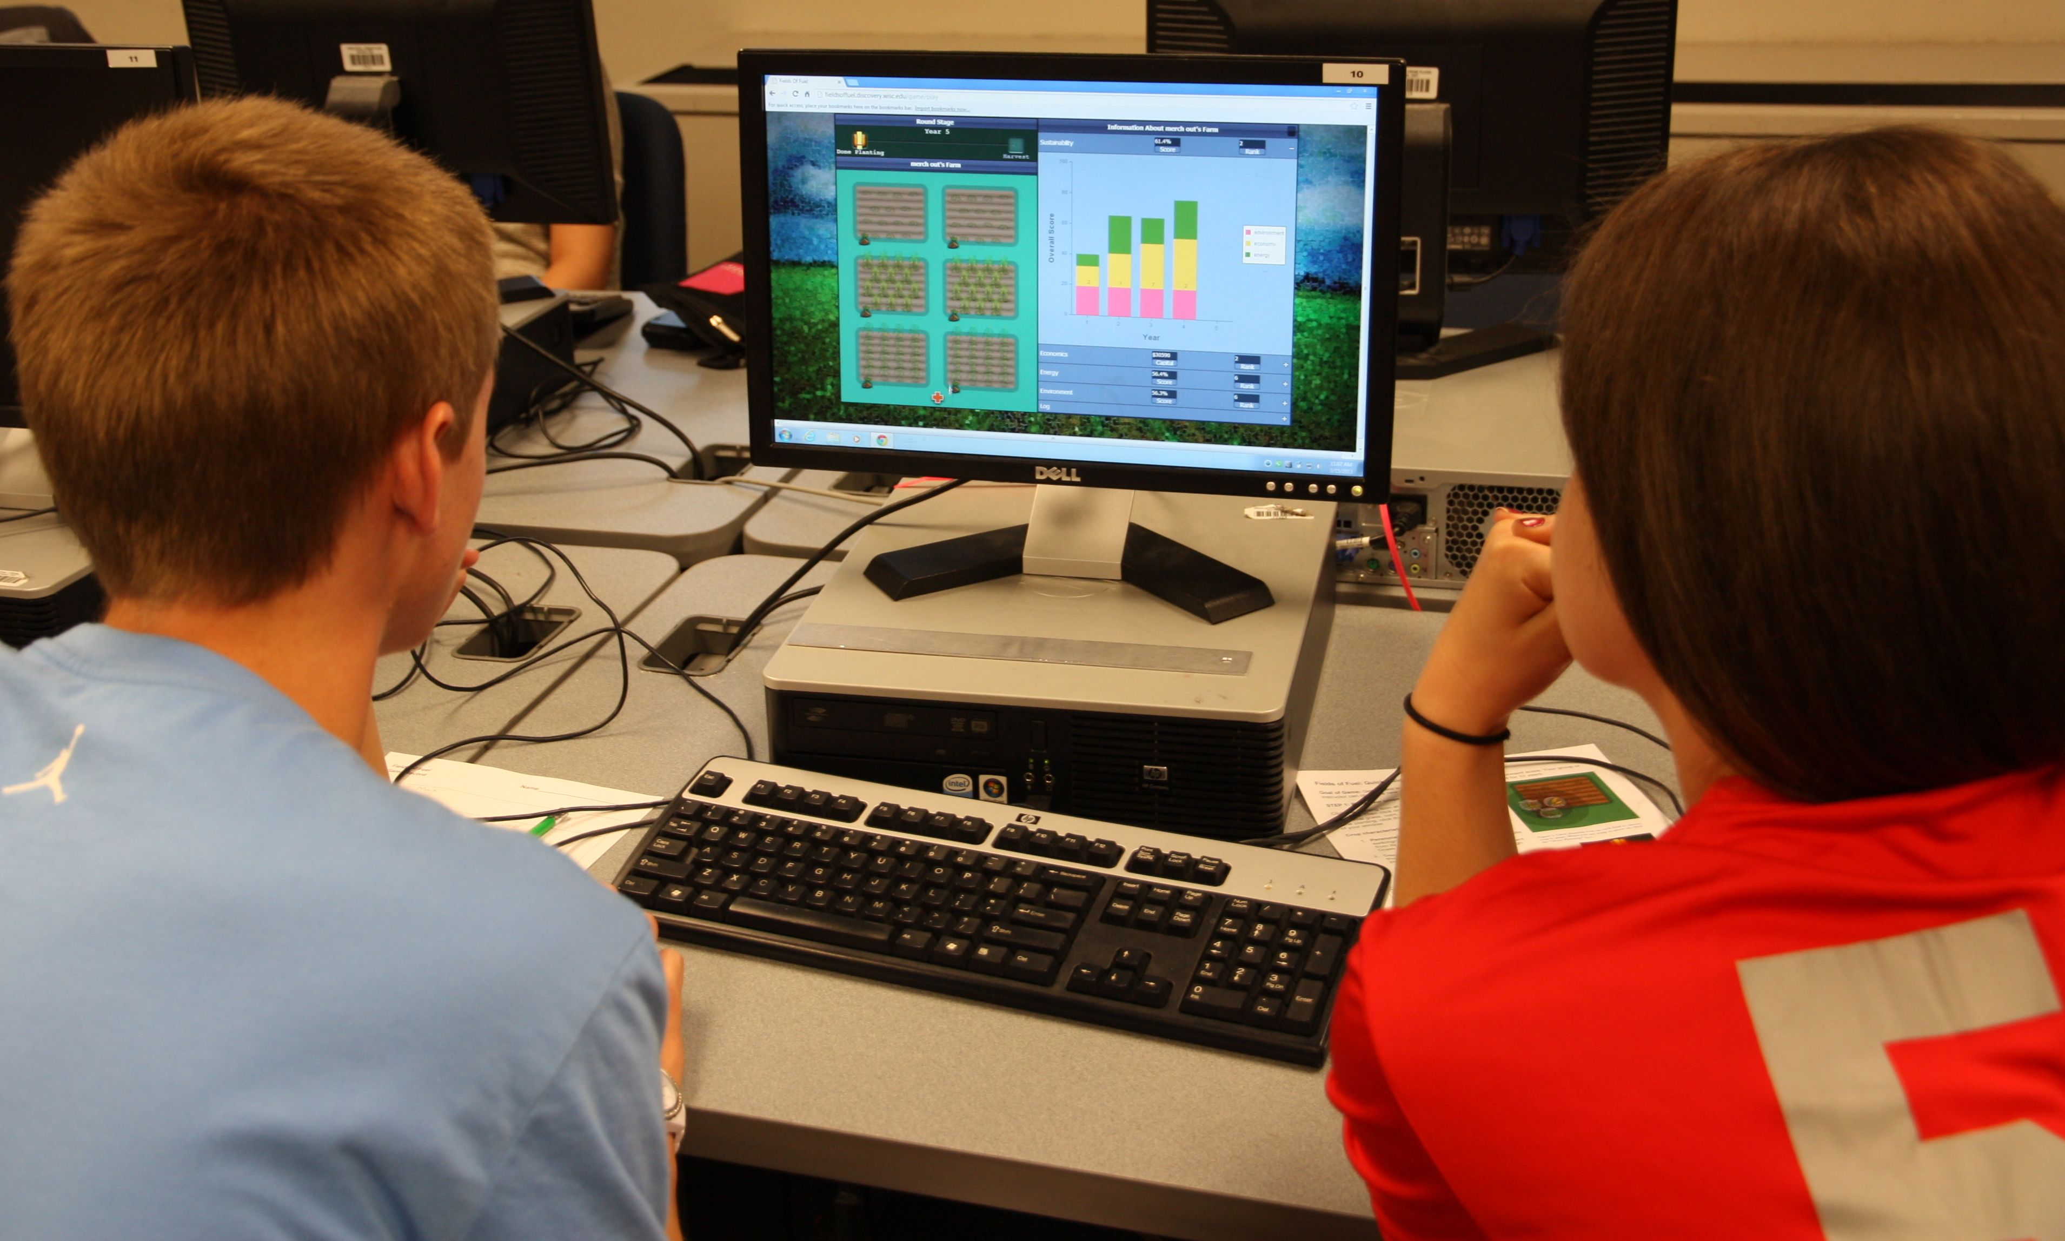

**Overview**: In this game, players - both students and the public - take on the role of farmers working to sustainably grow crops to produce energy resources, earn income and improve ecosystem services. In doing so, players engage in sophisticated systems-level thinking and learn about:

* Ecological and economic aspects of sustainability
* Short and long term dynamics of the sustainable systems
* Local and global impacts of individual farmer management decisions

Interacting with and making sense of game dynamics demonstrates the complexity involved with the sustainable production of bioenergy crops and helps to engage current research and sustainability in ways that are difficult with traditional instructional approaches.

**Primary audience and uses**: The game was designed primarily for use in high school and undergraduate environmental studies, agriculture, ecology, economics and natural resource management classes. However the game integrates numerous concepts across the life and social sciences and can be adapted for use in a variety of formal and informal educational settings. Game setup allows the user to adjust the level of complexity for students and audiences of different levels.

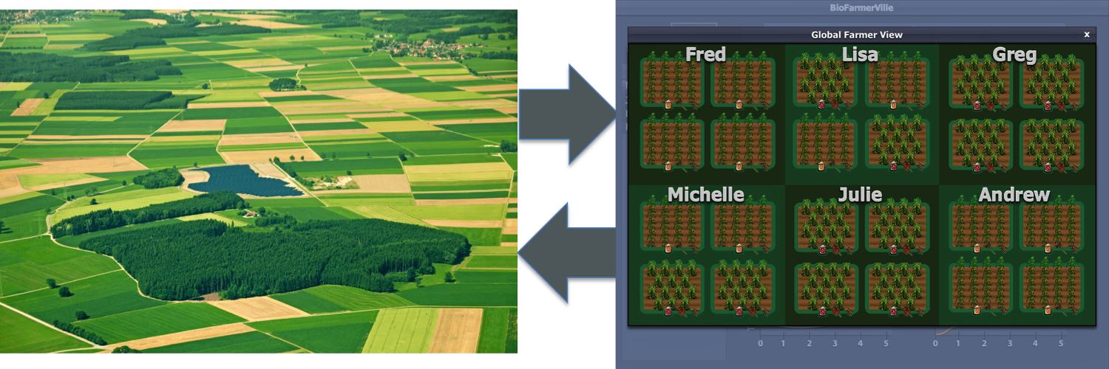

**Development**: The Fields of Fuel game is the result of a multidisciplinary collaboration between researchers and staff from the [UW Department of Curriculum and Instruction](http://ci.education.wisc.edu/), [Department of Computer Sciences](http://www.cs.wisc.edu/), [Great Lakes Bioenergy Research Center (GLBRC)](http://www.glbrc.org/), and [Wisconsin Institute for Discovery (WID)](http://discovery.wisc.edu/home/discovery/discovery-home.cmsx). The goal of the project was to create a multiplayer, web-based simulation game designed to educate players about the economic and environmental tradeoffs associated with the development of sustainable bioenergy cropping systems. This game combines expertise from computer scientists, bioenergy researchers, education scholars and classroom educators to create a tool that is both educational and scientifically accurate.

This collaboration also ties into a number of other projects, including the development of a decision support tool to evaluate policy decisions around biofuels production, as well as an online role playing game designed to crowdsource ecological and economic interactions in northern Wisconsin.